# **Topic: ECG Signal Processing and Heart Beat Rate Calculation Circuit**

**Task No.: Final Submission**

### INTRODUCTION :

The aim of this proposed project was to design an analog or mixed signal circuit for basic signal processing of ECG signals. The circuit was designed using operational amplifiers and aimed towards eliminating the noise in the ECG signal.

Task 1 :- In this task we researched about the ECG Signal Structure, its typical amplitude and the waves involved in the whole signal cycle. It also included the study of various types of noises present in the ECG Signals and their corresponding frequencies. We further studied the basics of operational amplifiers and the concepts of the amplifier and filter circuits.

Task 2 :- In this task we familiarised ourselves with the LTspice Software by implementing the Voltage Divider circuit.

Task 3 :- This task was performed in a team where each member contributed towards studying the concept and designing of circuits such as Low Pass Filter, High Pass Filter, Notch Filter, Non-inverting Amplifier and Comparator. The output was verified by taking the FFT of the waveform.

Final Task :- This task required combining of the circuits which were individually designed in Task 3. Here, the sequence in which these circuits were arranged and their specific configurations used were of key importance which contributed towards filtering of the provided noisy ECG signal sample.

### COMBINING OF BLOCKS :

The ECG signal measured is too feeble. So we first need to amplify the signal for which we have used a non-inverting amplifier. This is followed by a high-pass and then a low-pass filter which together act as a band-pass filter allowing only the required frequencies to pass through. Then we designed a notch filter in order to remove powerline noise. On amplifying the output of the notch filter we get our clean ECG signal. For that we designed an instrumentation amplifier as it increases the stability.

### SIMULATION OF DENOISING CIRCUIT AND FFT ANALYSIS:

#### Circuit:

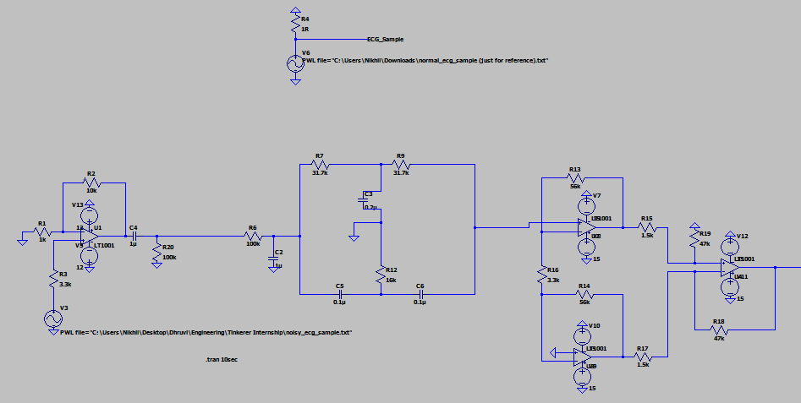

#### Output:

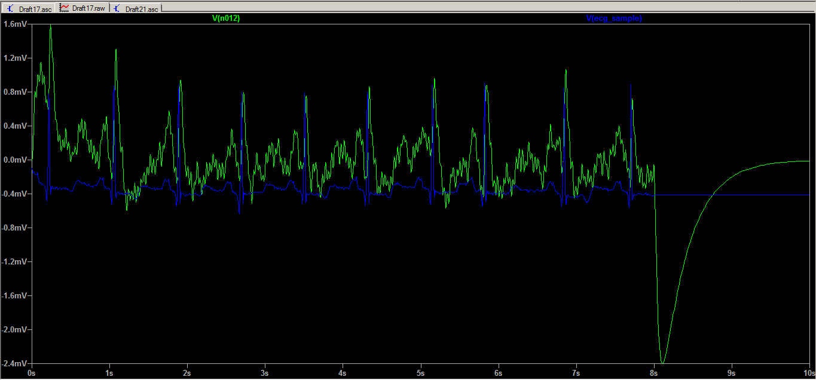

The Blue Curve in the output is the ideal output (clean ECG signal) and the Green Curve depicts the corresponding output obtained by us on designing the above circuit. The coinciding nature of the R peaks in both the signals verifies our output.

#### FFT:

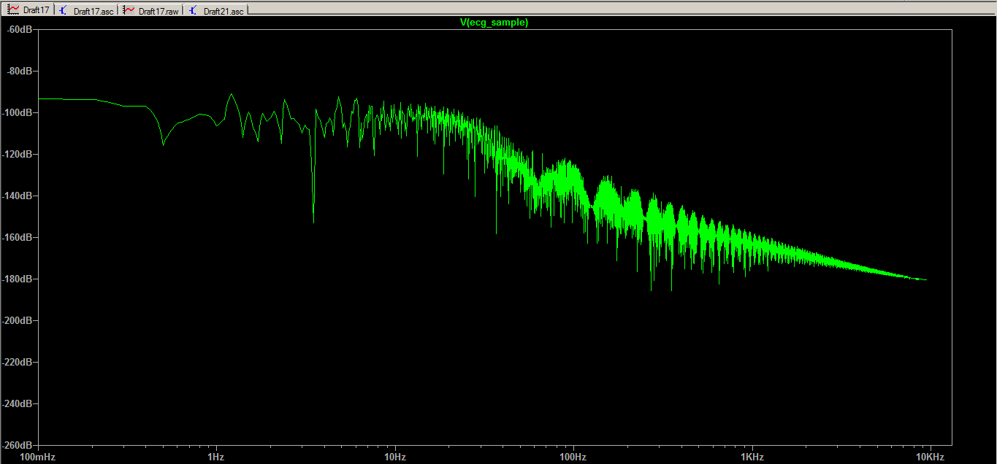

### COMPARATOR AND ITS ALTERNATIVES:

For our purpose , to get better denoised O/P we can use wave shaping circuits like clipper & clamper along with comparator/ as an alternative to comparator.

The clipper circuit is used to clip/ remove the unwanted part of the input above or below a reference value, whereas the clamper circuit can be used to produce an output similar to i/p with a dc level shift.

The other alternative that we can use for comparators is Schmitt trigger. In a normal comparator , the gain is very high due to the open loop and therefore even small noise can trigger the comparator and change its output. The advantage of using Schmitt trigger is that we can avoid false triggering by using a positive feedback.

### ISOLATION OF R PEAKS:

In order to isolate the R peaks we need to eliminate the other lower peaks by adding a comparator circuit. The clean ECG signal obtained is given as an non-inverting input to the comparator while the inverting terminal is grounded. The output here gives us only R peaks in the form of a square waveform which can then be counted by adding a counter. The number of R peaks represents the number of heart beats and hence heart beats can be calculated successfully.

### REFERENCES:

1. 2017, Raaed Faleh Hassan, Safa Majed Mohammed, International Journal of Emerging Science and Engineering (IJESE) <[L12010741217 (ijese.org)](https://www.ijese.org/wp-content/uploads/Papers/v4i12/L12010741217.pdf)>
2. 2021, h_salaman, instructables circuits, <[Electrocardiogram (ECG) Circuit : 7 Steps - Instructables](https://www.instructables.com/Electrocardiogram-ECG-Circuit/)>